**Royal Pharmaceutical Society(RPS)**

TABLE OF CONTENTS

1 Admin Page 3

2 Adding Nodes and Notes 3

1.1 Home Page 3

1.2 Adding a node 4

1.3 Editing an existing Node 6

1.4 Deleting an existing Node 7

1.5 Identifying Node Status 8

3 Snippets 8

2.1 Entry point ???? 8

2.2 Adding a Snippet 8

2.3 Editing a Snippet 9

2.4 Deleting an existing Snippet 10

2.5 Adding targets 10

4 Rules followed: 10

# Admin Page

The user selects the URL for Admin Page and gets the following page that gives him option to add/edit local content

<Snap shot needed>

# Adding Nodes and Notes

## Home Page

The page for Adding and amending nodes will appear as shown below (Figure 1).

The left section will show the tree (TOC) with options to add amend and delete nodes while the box on right would contain static text (to be provided by RPS)

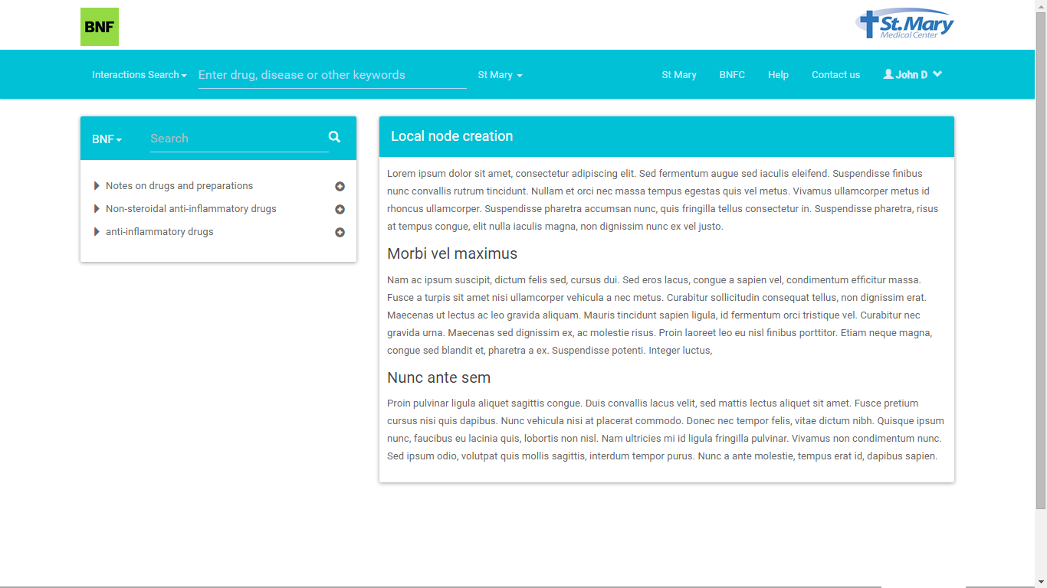

**Figure 1**

## Adding a node

When the user clicks on the icon for adding a node, the right hand side appears with a text box to enter the title of the node and a box to add the note for same.

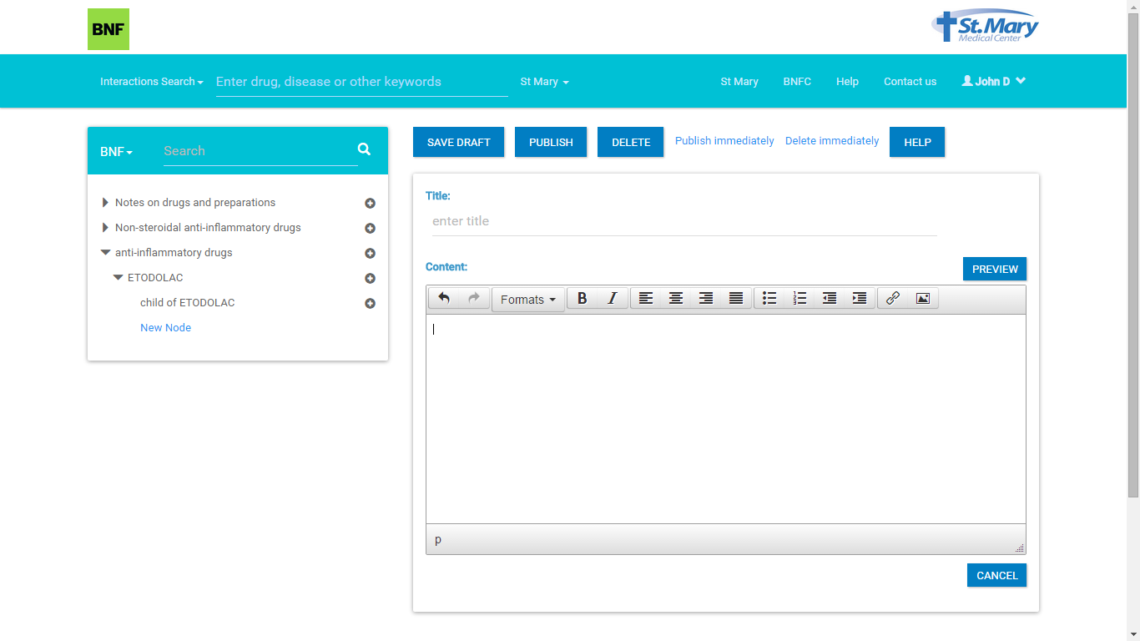

**Figure 2** <Delete immediately is to be removed>

The title is kept as mandatory, while the content can be left as blank. The user has an option to “save draft” “publish” or publish immediately (if the user is an administrator).

The user would fill contents for the new node , for example as shown below

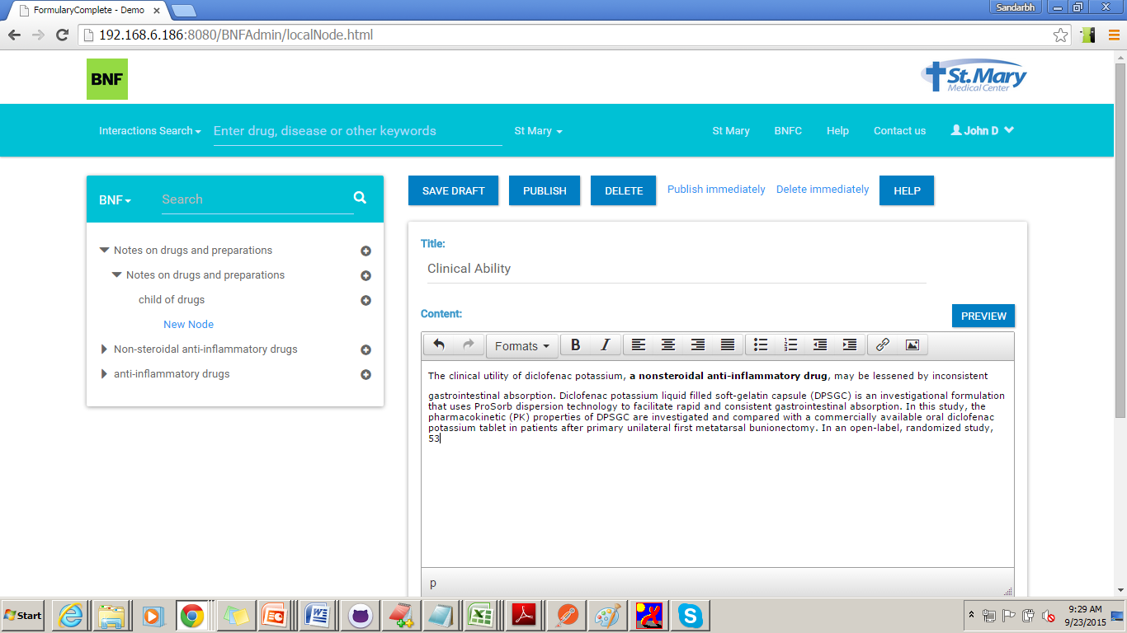

**Figure 3**

, The click on “Preview” will take user to a preview page

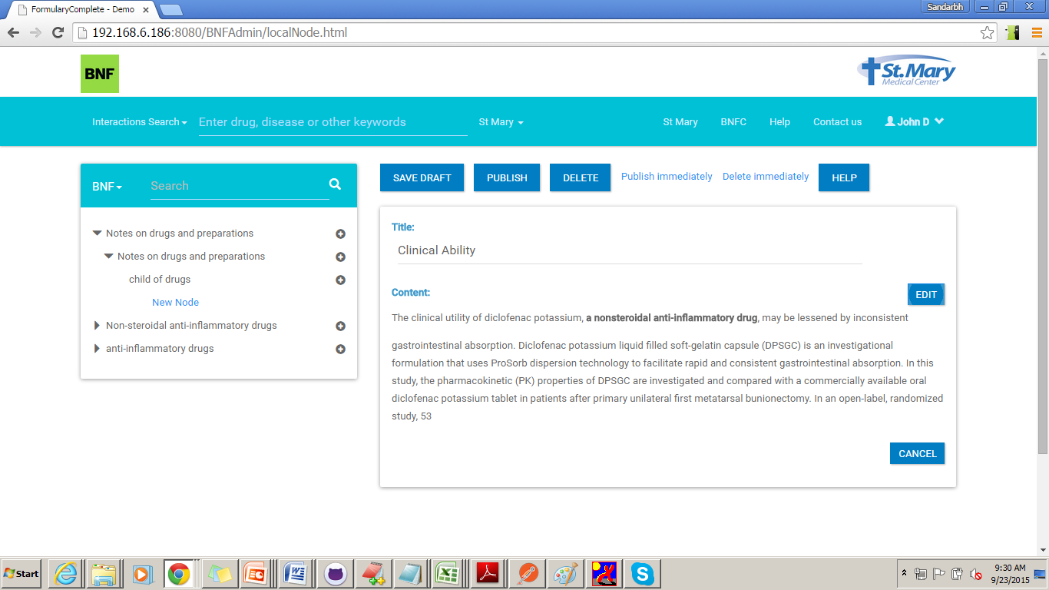

**Figure 4**

<Delete immediately is to be removed>

Clicking on “Save draft” would just save a draft in ES database.

Click on “Delete” will remove the newly added node and bring teh page back to Home Page (figure 1)

Click on “Publish” will send this for review

Click on “Publish immediately” will make this node available on the TOC immediately.

## Editing an existing Node

When a user selects a Node from home page the right section of the screen comes auto populated with the title and content of the node

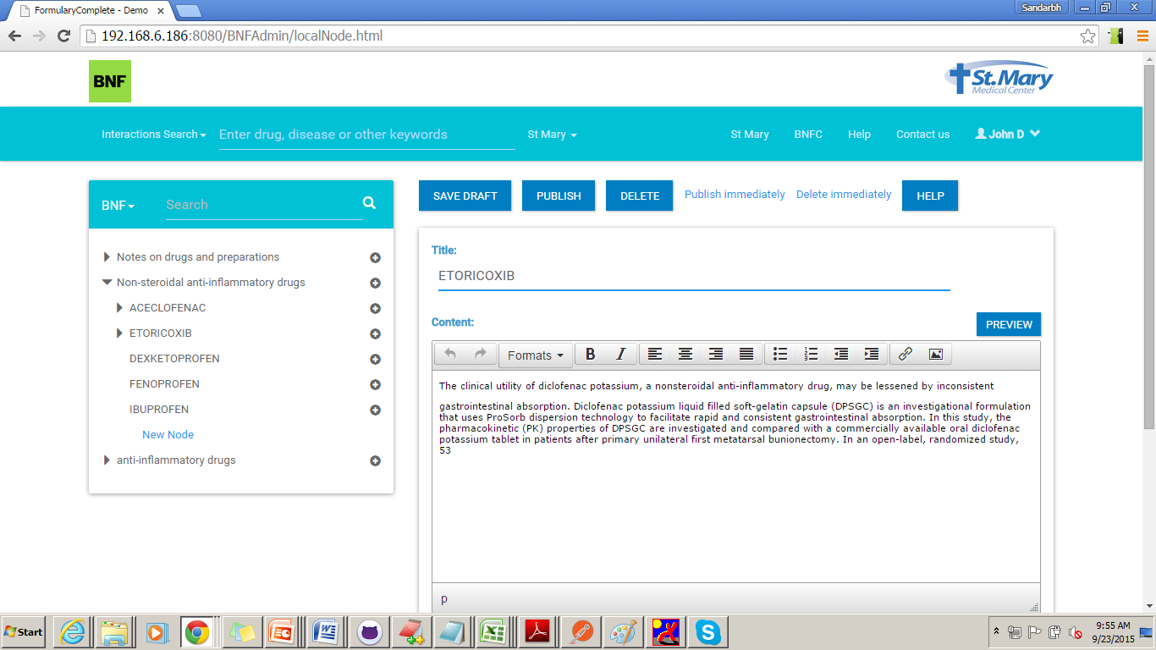

These options will appear for a user logged in as an administrator

The user would get the same set of options as for “Adding a New Node”, with an additional option of “Delete immediately”

Clicking on “Save draft” would just save a draft in ES database.

Click on “Publish” will send this for review

Click on “Publish immediately” will make this node available on the TOC immediately.

Once the user clicks on any of the above options, system will ask for confirmation for the action

<Need snapshots>

## Deleting an existing Node

The user will be able to delete a node, by first selecting the same from the TOC.



Click on “Delete” will send deletion request for approval and bring the page back to Home Page (figure 1)

Click on “Delete immediately” will remove the node and bring the page back to Home Page (figure 1)

Deletion of node, will not delete the node from database, but would just add effective dates to indicate that the node is no longer valid.

Once the user clicks on any of the above options, system will ask for confirmation for the action

<Need snapshots>

## Identifying Node Status

The TOC for admin, will show status for nodes.

The following status can be displayed

Pending Approval

Marked For Deletion

Draft version

<Need snapshots>

The node having any of these values will have addition of nodes as disabled.

<Need snapshots>

# Snippets



## Adding a Snippet

The page for adding a Snippet is as follows

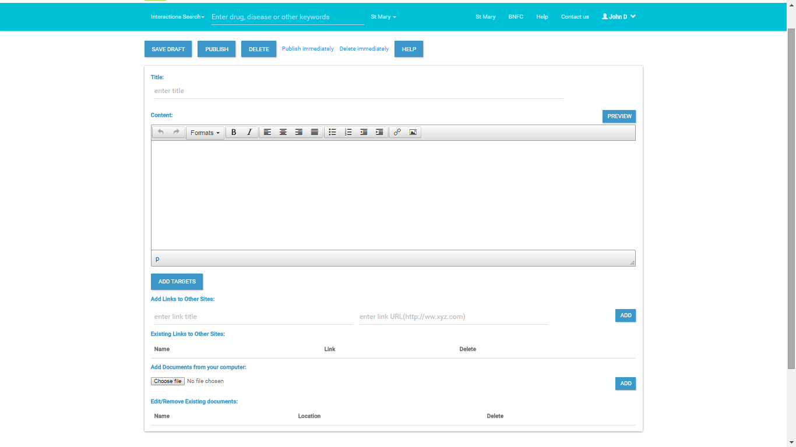

Clicking on “Save draft” would just save a draft in ES database.

Click on “Delete” will remove the newly added snippet and user will be directed back to Home Page (figure 1)

Click on “Publish” will send this for review

Click on “Publish immediately” will make this snippet available.

Options for “Delete Immediately” and Add targets will not be visible on add new screen

On click of “Preview”, the following screen would appear

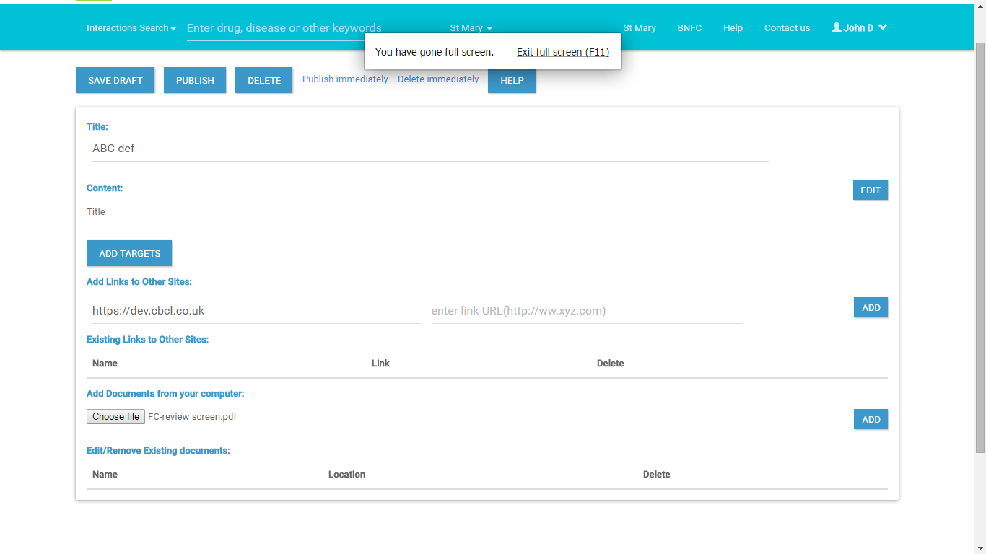 The user gets all options to save publish or delete the new snippet.

Options for “Delete Immediately” and Add targets will not be visible on add new screen

## Editing a Snippet

The screen for editing will have all options to save draft, publish and delete the new snippet.



Clicking on “Save draft” would just save a draft in ES database.

Click on “Publish” will send this for review

Click on “Publish immediately” will make this node available on the TOC immediately.

Once the user clicks on any of the above options, system will ask for confirmation for the action

<Need snapshots>

## Deleting an existing Snippet

<Need snapshots>

Click on “Delete” will send deletion request for approval and bring the page back to Home Page (figure 1)

Click on “Delete immediately” will remove the node and bring the page back to Home Page (figure 1)

Deletion of node, will not delete the node from database, but would just add effective dates to indicate that the node is no longer valid.

Once the user clicks on any of the above options, system will ask for confirmation for the action

<Need snapshots>

## Adding targets

The option to Add targets will be available **only** if the snippet is approved. On the Edit screen (Figure ) if the “Add Targets” button is clicked a new page with option to Add target appears.

<Need snapshots>

The user would see targets as pre-selected, and would have options to add or remove targets. (Do we need Save Draft here????)

Click on “Publish” will send these changes for review

Click on “Publish immediately” will make set these targest for the snippet.

Once the user clicks on any of the above options, system will ask for confirmation for the action

<Need snapshots>

# Rules followed:

1. Every Node has to have a content. This content can be blank.

2. The Node and its content have to be approved before they can be displayed on the TOC.

3. There can be a scenario where just the node having a blank content is approved.

4. Any change to content requires approval

5. A snippet requires an approval , and can exist independently.

6. Setting targets requires an approval as well.